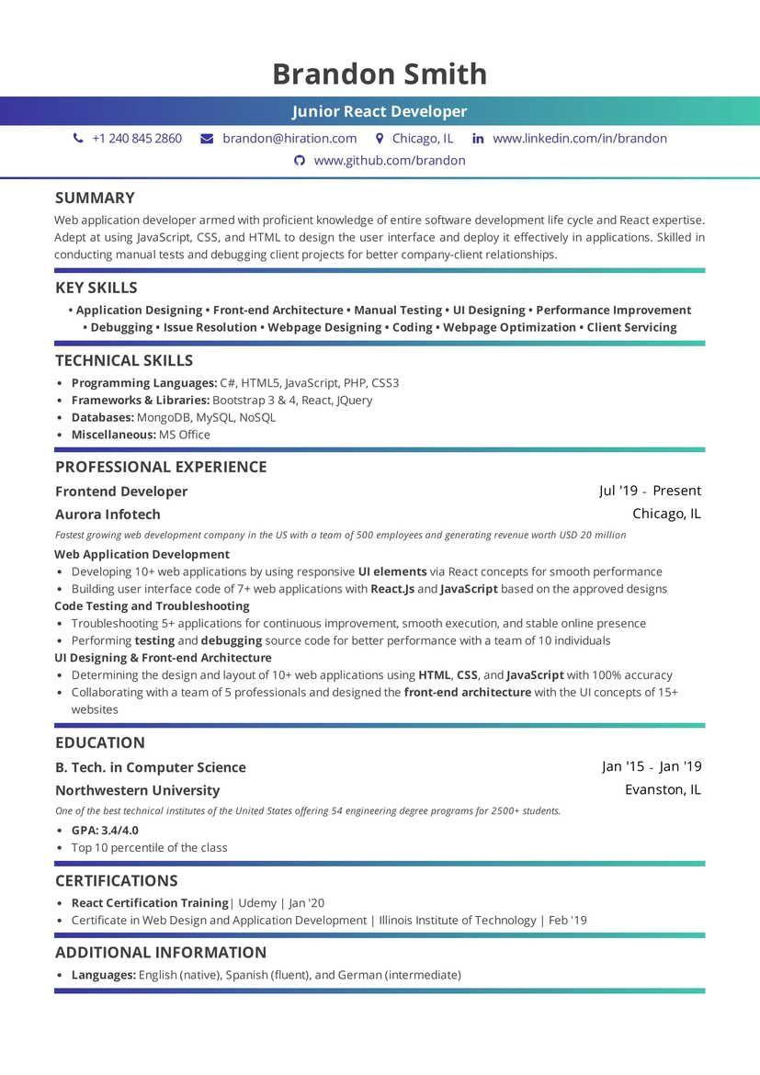
Brandon Smith
Junior React Developer
+1 240 845 2860
brandon@hiration.com
Chicago, IL in www.linkedin.com/in/brandon www.github.com/brandon
SUMMARY
Web application developer armed with proficient knowledge of entire software development life cycle and React expertise. Adept at using JavaScript, CSS, and HTML to design the user interface and deploy it effectively in applications. Skilled in conducting manual tests and debugging client projects for better company-client relationships.
KEY SKILLS
• Application Designing. Front-end Architecture Manual Testing UI Designing Performance Improvement
• Debugging. Issue Resolution. Webpage Designing. Coding Webpage Optimization Client Servicing
TECHNICAL SKILLS
• Programming Languages: C#, HTML5, JavaScript, PHP, CS53
• Frameworks & Libraries: Bootstrap 3 & 4, React, JQuery
⚫ Databases: MongoDB, MySQL, NOSQL
⚫ Miscellaneous: MS Office
PROFESSIONAL EXPERIENCE
Frontend Developer
Aurora Infotech
Jul '19 Present Chicago, IL
Fastest growing web development company in the US with a team of 500 employees and generating revenue worth USD 20 million Web Application Development
• Developing 10+ web applications by using responsive UI elements via React concepts for smooth performance ⚫ Building user interface code of 7+ web applications with React.js and JavaScript based on the approved designs Code Testing and Troubleshooting
• Troubleshooting 5+ applications for continuous improvement, smooth execution, and stable online presence
• Performing testing and debugging source code for better performance with a team of 10 individuals
UI Designing & Front-end Architecture
• Determining the design and layout of 10+ web applications using HTML, CSS, and JavaScript with 100% accuracy
• Collaborating with a team of 5 professionals and designed the front-end architecture with the UI concepts of 15+ websites
EDUCATION
B. Tech. in Computer Science
Northwestern University
One of the best technical institutes of the United States offering 54 engineering degree programs for 2500+ students.
• GPA: 3.4/4.0
• Top 10 percentile of the class
CERTIFICATIONS
• React Certification Training Udemy | Jan '20
• Certificate in Web Design and Application Development | Illinois Institute of Technology | Feb '19
ADDITIONAL INFORMATION
⚫ Languages: English (native), Spanish (fluent), and German (intermediate)
Jan '15 Jan '19 Evanston, IL

